Temperature Loggers – Approved List
November 25, 2014

LogTag
Model: TRIX-8 Temperature Recorder
http://www.logtagrecorders.com/products/trix.htm
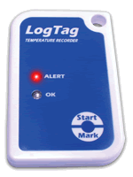
http://www.microdaq.com/logtag/index.php?gclid=CNLe0eLqhMICFUQF7AodrjIAuA

Sensitech
Model: TempTale 4 (TT4) Monitor
http://www.sensitech.com/products/temptale4
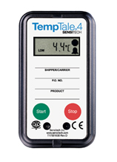
800 Cummings Center
Suite 258X
Beverly, MA 01915-6197
Phone: 800 843 8367

Cryopak
Model: Escort Intelligent MINI #MI-ST-D-2-L
http://www.cryopak.com/en/verification-products/data-loggers/intelligent-mini/
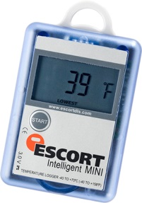

551 Raritan Center Parkway
Edison, NJ 08837
Phone: 732-346-9200

DeltaTrak – 2 models
Model: FlashLink VU In-Transit Data Logger #20741 (5 day recording period)
http://www.deltatrak.com/flashlink-vu-in-transit-data-logger

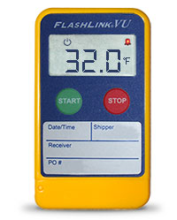

OR

Model: FlashLink USB In-Transit Data Logger #20911 (15 day recording period)
http://www.deltatrak.com/flashlink-usb-logger-in-transit-data-logger
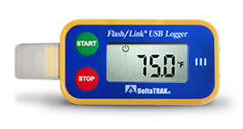
P.O. Box 398
Pleasanton, CA 94566
Phone: 800-962-6776

_______________________________________________________________________________
Cargo Data Corporation
Model: Quality Blue
http://cargodatacorp.com/full-line-of-products/quality-blue/

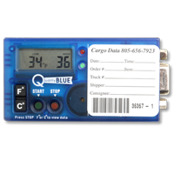
P.O. Box 6553
Ventura, CA 93006
800-338-8134

American Thermal Instruments
Model: Log-Ic USB Single Use Logger #3100
http://www.americanthermal.com/products/log-ic/products/usb/single-use/single-use

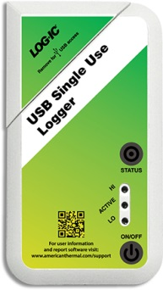

2400 E. River Road
Dayton, OH 45439
800-648-6339

